Dated: __________
CORPORATE / INSTITUTION NAME
STATE, COUNTRY
Strictly Confidential

Corporate Group Health Analysis

The Employee Health Risk Evaluation & Assessment Tool (HREAT) is an indicative assessment of an employee’s health status, based on information voluntarily provided by the employee during health screening. This assessment is designed to provide preliminary insights into current health conditions and the potential risk of developing chronic diseases, comorbidities, associated complications, and other health risk factors.
The employee risk assessment scan utilizes an AI-based algorithm and is conceptualized from Framingham’s assessment method. The assessment analyzes multiple health dimensions, including family medical history, current medical history, medication usage, systemic ailment status, diet and nutrition, physical fitness, stress levels, and health-related behaviors such as tobacco use, smoking, and alcohol consumption.
Based on the analysis, HREAT generates an individualized health report outlining the employee’s health status, along with personalized recommendations for managing, controlling, and potentially reversing signs and symptoms through appropriate lifestyle management and medical support. Additionally, a consolidated group health analysis is provided to the organization to support the planning and implementation of targeted employee well-being programs aimed at managing and preventing chronic health conditions.
Thank you for utilizing the Employee Health Risk Evaluation & Assessment Tool for the health screening of {count} employees/staff conducted between {s_date} and {e_date}.

Demographics:
  - Gender Distribution: Gender composition is a key determinant influencing metabolic function and susceptibility to cardio-metabolic syndrome.
The assessed population comprises ___% males and ___% females, indicating the gender-based metabolic risk distribution within the group.
  - Age Distribution: Age is a critical factor affecting metabolic efficiency and the likelihood of developing cardio-metabolic syndrome.
___% of the screened population is below 30 years of age, while ___% falls within the 31–40 year age group. Cumulatively, ___% of the population is under 40 years, whereas ___% is aged 40 years and above, representing a higher-risk cohort for cardio-metabolic and chronic health conditions.
  - Descent Profile: Geographical descent plays a significant role in metabolic health due to genetic predisposition and lifestyle influences.
The screened population comprises ___% Asian, ___% Middle Eastern, ___% African, and ___% European descent, providing insight into ethnicity-linked cardio-metabolic risk stratification within the group.

Lifestyle Status:
- Weight/BMI: Overweight and obesity has influence on overall health of an individual. Obesity is liked to various cardio- metabolic syndrome.
- Under Weight: __ % of your group is Under Weight with BMI below 18.9 Kg/m²
- Normal Weight: __ % of your group is Normal Weight with BMI between 19 to 25 Kg/m²
- Over Weight: __ % of your group is Over Weight with BMI between 25.1 to 29.9 Kg/m²
- Obese: ___ % of your group is Obese with BMI over 30 Kg/m²
- ___ % are found to be Gr I obese with BMI between 30 – 35 Kg/m²
- ___ % are found to be Gr II obese with BMI between 35.1 – 39.9 Kg/m²
- ___ % are found to be grossly obese with BMI above 40 Kg/m².

- Nutrition & Dietary Profile:
  - __ % of your group has overall faulty diet.
  - __ % of your group are under nourished as they lack eating fruits & vegetables more than 2 days a week. They may lack in vitamins & essential minerals.
  - __ % of your group has rich diet as they consume fried food, fast food, commercial food more than 3 days a week.
  - __ % of your group are prone to employee as they consume juices, soft drinks, sugary snacks, fried food, fast food, commercial food more than 3 days a week.
  - __ % of your group may develop dehydration as they consume less of fluids as per RDA.

- Physically Fitness Profile:
  - __ % of your group has sedentary lifestyle.
  - __ % of your group is overall physically unfit due to various reasons such as obesity, back pain, etc.
  - __ % of your group has low flexibility of functional muscles.
  - __ % of your group has low strength of functional & core muscles.
  - __ % of your group are low in stamina which includes impaired heart rate and low lung capacity.
- Stress Profile:
- Overall Stress & Presenteeism: ___% of the assessed population exhibits elevated levels of overall stress and presenteeism, indicating a potential impact on productivity, engagement, and overall health outcomes.
- Home & Social Stress: ___% of the group reports significant stress arising from home and social factors, which may contribute to mental fatigue, reduced coping capacity, and spillover effects on workplace performance.
- Work-Related Stress: ___% of the population experiences high levels of work-related stress, highlighting occupational stressors that may increase the risk of burnout, absenteeism, and chronic health conditions.
- Health Habits & Dependency Profile:
- Tobacco Use (Oral & Smoking): ___% of the assessed population reports engagement in tobacco use, including oral tobacco and smoking. This behavior places the identified cohort at an elevated risk for metabolic disorders, cardiovascular disease, respiratory conditions, and long-term chronic health complications.
- Alcohol Consumption: ___% of the group reports regular alcohol consumption, which may contribute to metabolic imbalance, liver-related conditions, increased cardiovascular risk, and adverse mental health outcomes, depending on frequency and intensity of use.

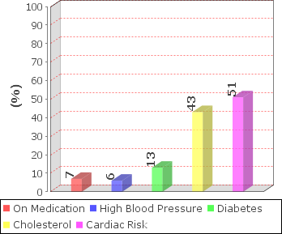
Medical Status:
  - Chronic Ailments: ___ % of your employees indicate to suffer from chronic health issues, such as diabetes, hypertension, dyslipidemia, musculoskeletal and neurological issues.
  - Medication: __ % of your employees are on chronic / frequent medication for various reasons.
- __ % of your employees are on medication for diabetes.
- __ % of your employees are on medication for hypertension.
- __ % of your employees are on medication for dyslipidemia.
- __ % of your employees are on medication for musculo-skeletal problems.
- __ % of your employees are on medication for other health problems.
  - Employee’s Blood Glucose Profile: (will be displayed according to test done: fasting or random)

(Fasting Blood Glucose)
    - __ % of your group are rated as Pre-Diabetic with a Fasting Blood Glucose levels between 101 to 110 mg/dl.
    - __ % of your group are rated as Moderately Diabetic with Fasting Glucose levels between 111 to 139 mg/dl.
    - __ % of your group are rated as Diabetic with Fasting Glucose levels above 130 mg/dl.

(Random Blood Glucose)
- __ % of your group are rated as Pre-Diabetic with a Random Blood Glucose levels between 161 to 200 mg/dl.
- __ % of your group are rated as Moderately Diabetic with Random Glucose levels between 201 to 249 mg/dl.
- __ % of your group are rated as Diabetic with Random Glucose levels above 250 mg/dl.

  - Employee’s Blood Pressure Profile:

    - __ % of your group are rated as Pre-Hypertensive with a Systolic Blood Pressure between 135 to 140 mm of Hg or Diastolic Blood Pressure between 85 to 89 mm of Hg.
    - __ % of your group are rated as Gr I - Hypertensive with a Systolic Blood Pressure between 141 to 159 mm of Hg or Diastolic Blood Pressure between 90 to 99 mm of Hg.
    - __ % of your group are rated as Gr II- Hypertensive with a Systolic Blood Pressure between 160 to 179 mm of Hg or Diastolic Blood Pressure between 100 to 109 mm of Hg.
    - __ % of your group are rated as Gr III- Hypertensive with a Systolic Blood Pressure above 180 mm of Hg or Diastolic Blood Pressure above 110 mm of Hg.
  - High Cholesterol:

- __ % of your group are rated as Borderline Hyperlipidemia with total Cholesterol levels between 201 to 219 mg/dl.
- __ % of your group are rated as Moderate Hyperlipidemia with total Cholesterol levels between 220 to 250 mg/dl.
- __ % of your group are rated as Hyperlipidemia with total Cholesterol levels above 251 mg/dl.
  - Cardiac Risk:
__ % of your group are indicated to have Cardiac Risk as a consequence of Family History, current medical history and contributing factors such as impaired glucose levels, high blood pressure, high heart rate, high cholesterol-triglyceride levels, smoking, oral tobacco, alcohol and high stress.

ANNEXURES:
Annexure - I: List of employees who underwent the screening.
Annexure - II: Micro Health & Lifestyle Analysis

RECOMMENDATIONS: Based on the above group profile and in order to improve the health & productivity of employees, through Education & Empowerment, we recommend as follows:
1.) Counseling Sessions: For ____ employees (total number of employees screened). (Same as Annexure - I)
2.) Disease Management Session: For ____ employees (number of employees cardiac risk). (Annexure - III)
3.) Stress Management Session: For ____ employees (number of employees high stress). (Annexure - IV)
4.) Dependencies Management Session: For ____ employees (number of employees in dependency). (Annexure - V)
5.) Exercise & Fitness Session: For ____ employees (number of employees High BMI). (Annexure - VI)
6.) Nutrition & Weight Management Session: For ____ employees (number of employees High BMI). (Annexure - VII)

Arabian Wellness & Lifestyle Management, LLC .
c/o RAK Hospital, RAK, UAE

Annexure - I
_____ , 20__ Strictly Confidential

The following employees (___) have undergone the Employee Risk Assessment & Counseling on ____.

Sl. No | Emp Id | Name | Department
1
2
3
4
5
6
7
8
9
10
11
12
13
14
15
16
17
18
19
20
21
22
23
24
25
26
27
28
29
30
31
32
33
34
35
36
37
38
39
40
41
42
43
44

Date:___________Strictly Confidential
Annexure - II
MICRO HEALTH & LIFESTYLE ANALYSIS

A - NUTRITION & DIET

Sl. No | Parameter | % Yes | % No
1. | Daily intake of fruits or vegetables
2. | Milk/ Curd or Eggs at least 2 - 3 times a week
3. | 6 - 8 glasses of water daily
4. | Frequent intake of sweets, aerated drinks, fast food 2 - 3 days a week

B - EXERCISE & FITNESS

Sl. No | Parameter | % Yes | % No
1. | Daily exercise for 30 minutes or more (including walking)
2. | Toe touch
3. | Push up/ Sit up (10 if below years; 5 for others)

Inadequate Diet Habits Poor Physical Fitness
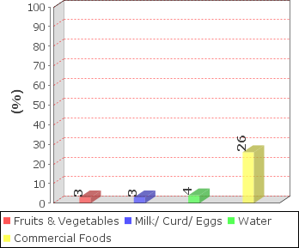
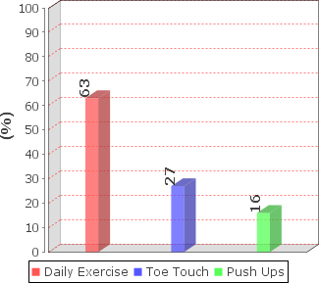
*97 Max Score Achievable

Date:___________Strictly Confidential
C - STRESS

Sl. No | Parameter | % Yes | % No
1. | Job Satisfaction (salary, working condition, etc)
2. | Good Home Situation (parents, spouse, children,etc)
3. | Major Problems (work, home, financial problems, etc)
4. | Sufficient sleep

D - HEALTH BEHAVIOUR

Sl. No | Parameter | % Yes | % No
1. | Alcohol consumption
2. | Smoking
3. | Oral Tobacco
4. | Health Safety

E – Blood Glucose Levels

Sl. No | Parameter | % Yes | % No
1. | Known Diabetics and on Medication
2. | Known Diabetics and Not on Medication
3. | Family History of Employee
4.

Poor Stress Parameters Poor Health Behaviour & Safety
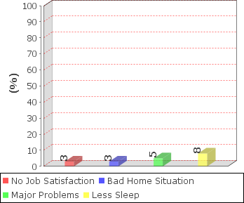
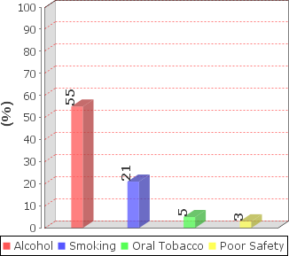
*97 Max Score Achievable

NOTES:

- Employee Status
  - Pre-Employee
  - Newly Employee
  - Known Employee without medication
  - Known Employee on medication
  - Uncontrolled Employee
- Ailment Comorbidity Risk

- Fitness Status
- Nutrition Status
- Stress Status
- Dependency Status

